

Through Lived experience of numerous EHCP’s and supporting many individuals throughout their journeys, SEN PSG have come up with “what makes a good EHCP” document to assist you on your journey.
Describing the main contributions of a good Plan that is both person centred and compliant with the legislation and the requirements of the Special Educational Needs and Disability (SEND) Code of Practice (CoP) 2015.
A good EHC Plan is one that is clear about the SEN and / or disability that relate to an individual child or young person’s learning and development, the outcomes they would like to achieve and the provision needed to achieve those outcomes. A good EHC Plan should also be easy to read and understand. It should not be an overly lengthy document (usually 10-15 pages) but use the information provided to clearly reflect the unique qualities and circumstances of the child or young person it is written for.
Each individual plan should provide the child, family, education provider and all other practitioners involved with a clear set of outcomes (typically 6-8) and provision to improve learning outcomes and opportunities for the child and young person. A good Plan should build on the activities and resources already in place for the child or young person that support their learning and opportunities.
As part of the EHC needs assessment, advice must be sought from the child’s parents, the child and all partners in education, health and social care. The requirement for EHC Plans is to include advice that is directly related to the child or young person’s SEN. Health and social care needs that do not relate to the child or young person’s learning needs will not usually be included within the EHC Plan but set out in another plan which is linked to the EHC Plan.
The main focus of all EHC Plans is to improve the learning outcomes and opportunities of children and young people with SEND, the gap that exists between these children and their peers should not exist.
LA’s will try to understand the aspirations, hopes and dreams of children and young people, then and only then can you begin to understand the barriers that exist for individuals and set out the right direction of travel, of course young children of primary age may not have collected their thoughts on aspirations therefore quite simply work on being on a par with peers and reaching their individual potential. ‘Outcomes should always enable children and young people to move towards the long-term aspirations of employment or higher education, independent living and community participation’ (Code of Practice, 9.64) If a child or young person is to be at the heart of an EHC Plan, a clear principle underpinning the SEND Code of Practice 2015, every effort should be made to seek and understand a child or young person’s thoughts, feelings and aspirations so that it can be truly person-centred.
It should be clear in Section A of the EHC Plan whether the ‘voice’ of the child or young person is being communicated or whether the contribution is from another person in a position of ‘advocate’ and perhaps sharing more of his/her ideas and not really those of the child or young person. For example: In Section A of this young person’s EHC Plan, his/her aspirations and goals include:
“I want to get out and meet other young people and have some fun! I would like to work with computers and maybe something involving numbers.” This was followed by: “The LD Assessment records that ‘name of young person’ would like to go to college every day as he didn’t see the point of the two hours activity offered at his former college.”
How do the aspirations of a child or young person link to the rest of the EHC Plan?
Delivering Better Outcomes Together, a consortium of Mott MacDonald, Council for Disabled Children and NDTi, explain the link between aspirations and planning as the ‘golden thread’. Please see below. This shows that the relationship between aspirations, needs, outcomes and provision is a two-way continuum. Children and young people’s aspirations set the direction of travel in terms of understand needs (barriers), setting relevant outcomes (building strengths) and agreeing appropriate provision. As outcomes are achieved, a child or young person’s aspirations may become further refined or even change, which should continue to inform the correct direction of travel.

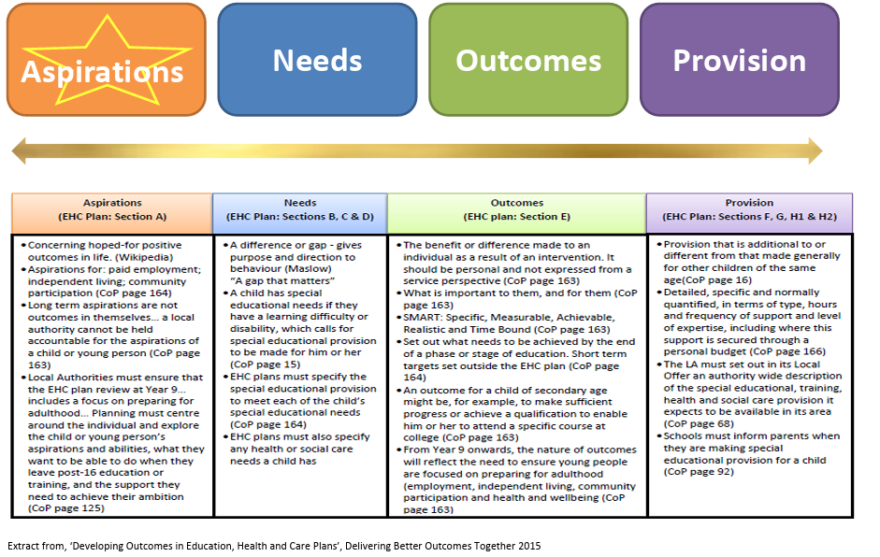
When describing needs there should be a clear description of all of the child or young person’s special educational needs specified in section B of the Plan. Where there are health or social care needs that relate to a child or young person’s learning and opportunities, these must be specified in the relevant sections B and C.
It should be clear from all of these descriptions how the needs relate to the child or young person’s learning and development. Contributors to the EHC needs assessment have a very important role in ensuring the description and/or assessment provided makes the relationship between needs and impact on learning clear.
What does the Code of Practice say?
‘An outcome can be defined as the benefit or difference made to an individual as a result of an intervention. It should be personal and not expressed from a service perspective; it should be something that those involved have control and influence over, and while it does not always have to be formal or accredited, it should be specific, measurable, achievable, realistic and time bound (SMART).’
(Code of Practice, 9.66) ‘Outcomes underpin and inform the detail of EHC Plans. Outcomes will usually set out what needs to be achieved by the end of a phase or stage of education in order to enable the child or young person to progress successfully to the next phase or stage.’
(Code of Practice, 9.68) Outcomes in an EHC Plan should focus on achieving improvements to a child or young person’s learning and development. Outcomes should link directly to achieving a benefit or difference to the barriers or needs that have been described in Sections B, C or D. Outcomes should also set out what is to be achieved by the end of a phase or stage of education to enable the child to progress successfully to his/her next stage of learning.
This means that outcomes in an EHC Plan should: • Link clearly to the child’s aspirations and needs (see the ‘golden thread’ in Developing Outcomes in EHC Plans) • Be Specific, Measurable, Agreed, Realistic & Timed (SMART) • Cover a key stage or phase of education e.g. ‘By the end of key stage 2, Sonny can write descriptive text in structured paragraphs’ or ‘By the end of key stage 3, Maia can use a communication aid to make her needs known, show her preferences and make choices in school, home and in the community’ • Specify the arrangements for setting shorter term milestones / outcomes e.g. ‘Advice for monitoring progress and setting next steps to achieve this longer term outcome will be provided from the ATS during a school visit each term. These shorter term outcomes or milestones will be set within a separate and more detailed plan (My Plan) and reviewed every 6-12 weeks by the SENCO. This separate plan and reviews will inform the annual review of the EHC Plan and provide evidence to inform progress towards achieving this outcome.’
Transition between key stage or phase of education: At a phase transfer reviews, i.e., when a child or young person is nearing the end of a key stage, and where an outcome has not been fully met or new outcomes are required, consideration should be given to extending it beyond the end of the current key stage to reflect what needs to be achieved over the next key stage or in the next setting. It is important that representation from the receiving setting is invited to attend the phase transfer annual review to help develop these and support the discussion around provision required. However, the outcomes set should be those that are relevant for the child/young person and not dependent on the setting they will be moving onto.
How do LA’s incorporate special educational provision into an EHC Plan?
They assess! Usually this is done by an Educational Psychologist however you can request SaLT and any other assessment you deem appropriate based on your childs presentation. This information would go into section B and form the basis of the plan. Part F of an EHC Plan sets out the special educational provision required by the child or young person. It should be clear about what provision is from the education provider’s delegated SEN budget (e.g. schools) and what is to be funded by the local authority top up funding. Advice and reports provided as contributions to the EHC Plan should be clear on the provision and interventions needed to meet the outcomes of the Plan and include details of who/where/how often i.e. specific and quantifiable. The advice should indicate where provision is simply continuing for the child e.g. SALT or OT and that which is additional to the services that are available to the child or young person via commissioned services or the education provider’s delegated funding for SEN. This level of specificity allows everyone involved in the Plan to be clear about what needs to happen, who will do it and how often. It also allows for a clearer understanding of what is normally available within education provision to support a child or young person’s SEN and what is additional which requires top up funding. This level of detail will also inform when an EHC Plan is no longer needed and can be ceased.
How LA’s incorporate social care provision into an EHC Plan?
Once outcomes within a Plan have been agreed, the provisions needed to achieve these outcomes must be clearly stated in Sections F, G & H1/H2. Sections H1 and H2 are the areas where social care can specify the provision that either must be made for a child under 18 resulting from section 2 of the Chronically Sick and Disabled Persons Act 1970 (H1) or that is reasonably required by the learning difficulties or disabilities which result in the child or young person having SEN (H2). Often the timescales for setting and reviewing outcomes are very different to meet both the requirements of an EHC Plan and the requirements of social care statutory processes. In these cases, it may be more appropriate to indicate within the EHC Plan, that the arrangements in place for social care provision are specified within a separate plan so that these differing timescales and requirements can be adhered to. This approach would fit within the guidance in the Code (9.69) quoted below.
How LA’s incorporate health provision into an EHC Plan?
Health provision that contributes towards outcomes that address a child or young person’s SEN should be specified in Section G of the EHC Plan, unless the provision recommended (mostly related to therapeutic provision) is to directly support learning (train or educate). In these cases, the provision would be specified in Section F (special educational provision).
What does the Code of Practice say about setting shorter milestone outcomes?
‘The EHC plan should also specify the arrangements for setting shorter term targets at the level of the school or other institution where the child or young person is placed. Professionals working with children and young people during the EHC needs assessment and EHC plan development process may agree shorter term targets that are not part of the EHC plan. These can be reviewed and, if necessary, amended regularly to ensure that the individual remains on track to achieve the outcomes specified in their EHC plan. Professionals should, wherever possible, append these shorter term plans and targets to the EHC plan so that regular progress monitoring is always considered in the light of the longer term outcomes and aspirations that the child or young person wants to achieve.’ (Code of Practice, 9.69) The CoP is clear that shorter term milestones / outcomes towards achieving the outcomes which have been set over a key stage or phase of education should be set out in an accompanying plan that can be attached to the EHC Plan but reviewed and amended as needed to ensure everyone is on track to achieve the outcomes in the EHC Plan.
For example some LA’s have My Plan and My Plan+, which is a Early Help Plan formats which are for setting out and reviewing shorter term milestones towards longer term outcomes. The CoP is also clear that these shorter term milestones are set and reviewed at least three times each year.
‘Where a pupil is receiving SEN support, schools should talk to parents regularly to set clear outcomes and review progress towards them, discuss the activities and support that will help achieve them, and identify the responsibilities of the parent, the pupil and the school. Schools should meet parents at least three times each year.’
(Code of Practice, 6.65) Linking other plans to EHC Plans There is a section within the front of an EHC Plan to show if there are other plans in place for a child or young person. This will inform practitioners and help them to link up as appropriate. An Early Help Plan format such as My Plan or My Plan+ can be used by education providers to set out the shorter term targets towards achieving the longer term outcomes within an EHC Plan, (as described above).
If a child or young person has health or social care needs that don’t relate to their learning needs, the same Early Help Plan can be used to set these out so that shorter term milestones across learning, health and care are planned for and worked towards concurrently. Early Help Plans have more frequent reviews (6 weekly or 3 monthly as agreed by the Team Around the Child TAC) which allow progress to be monitored and any necessary adjustments to be made to ensure all is on track to help the child or young person make good progress. This information can be used to inform the EHC Plan annual review.
Summary, the main focus and aim of an EHC Plan is to set out clearly the needs, outcomes and provision agreed that is required to help a child with SEND to achieve their learning and development potential. Underpinning this should be a good understanding of the child and his/her aspirations and views.
Advice and contributions to the EHC Plan should focus on providing a clear description of needs and how they impact on the child or young person’s learning and opportunities.
The proposed outcomes should span a stage or phase of education and specify the arrangements that will be in place to set shorter term milestones / outcomes.
Advice and contributions to the EHC Plan should also specify and quantify the provision needed in order to achieve the outcomes set out. If this hasn’t been included, then it should be clarified during the TAC meeting and Plan drafting stage, otherwise the contribution is incomplete and difficult to include within the legal requirements of the Plan.
Examples of aspirations, needs, outcomes and provision illustrated below to show you how these need to be SPECIFIC to remove his/her needs or barriers from learning.
The quality of the final EHC Plan is very dependent on the clarity of this advice, the contributions made and the effort to ensure everyone understands the aspirations and views of the child or young person.
Below is a typical plan that is none specific and I have noted at the end key learning from each plan to assist in obtaining a Quantifiable and SMART EHCP.

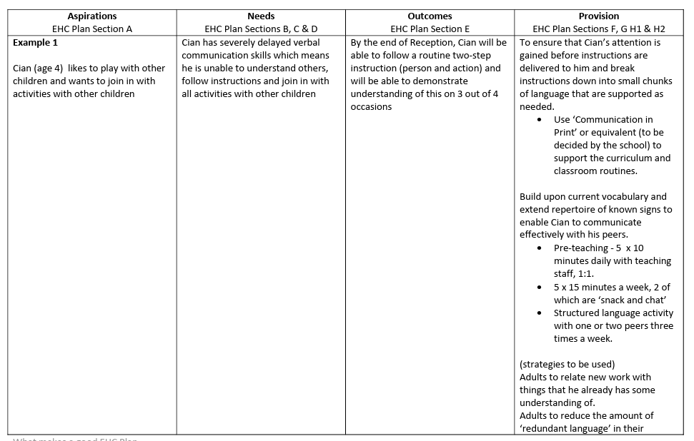
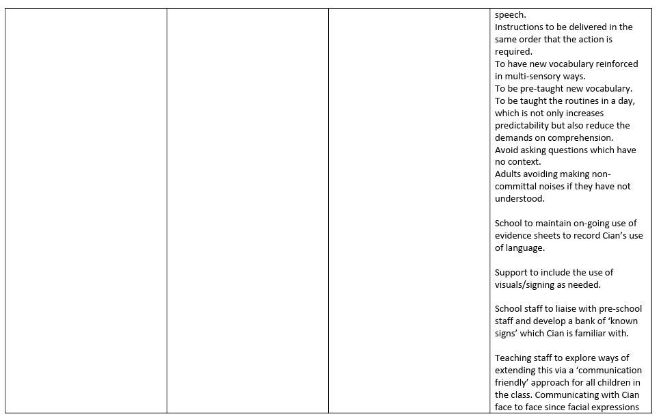

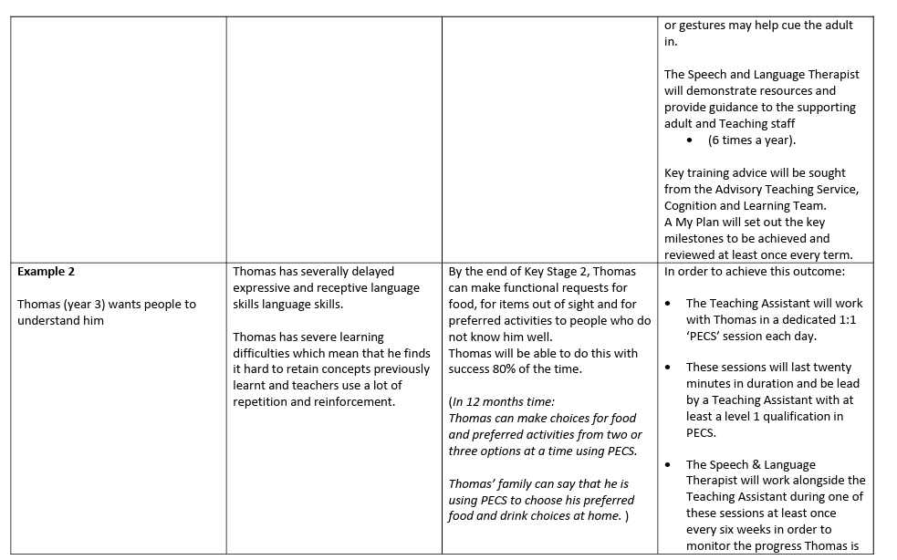
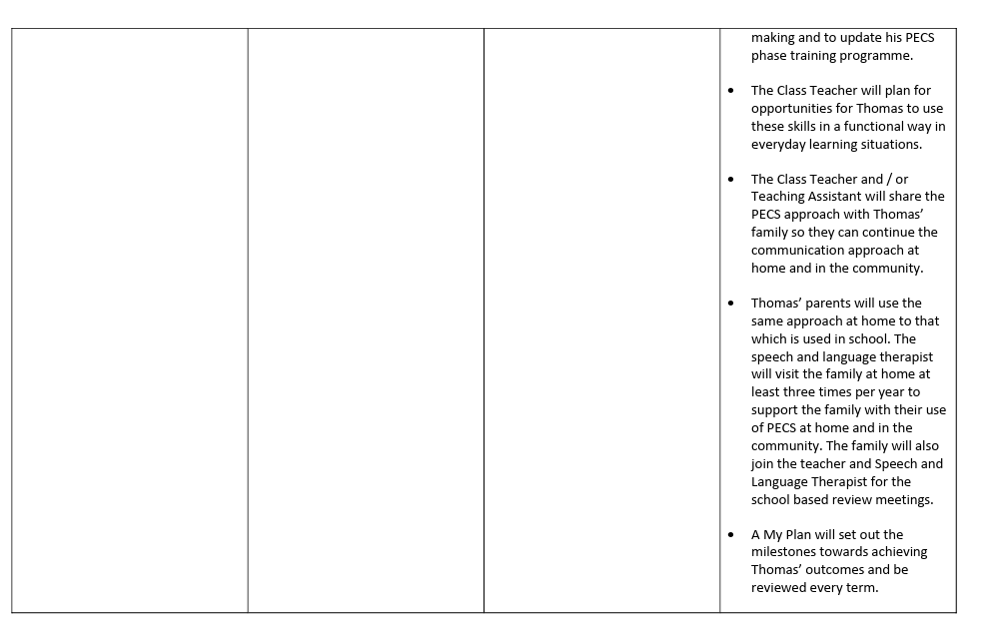

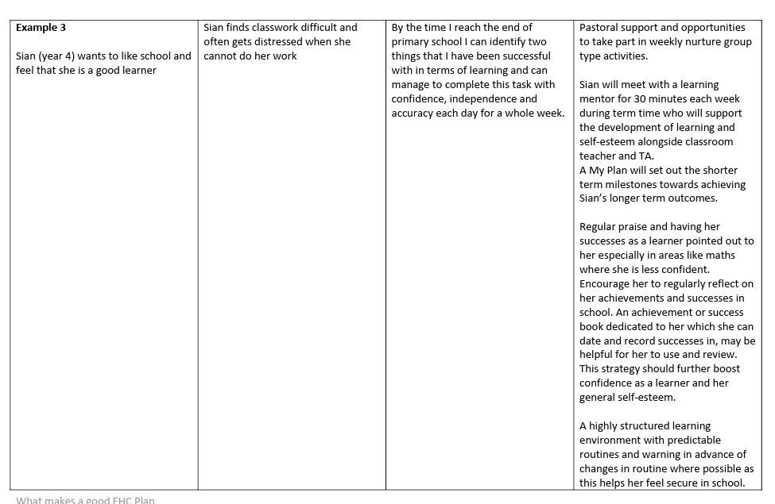
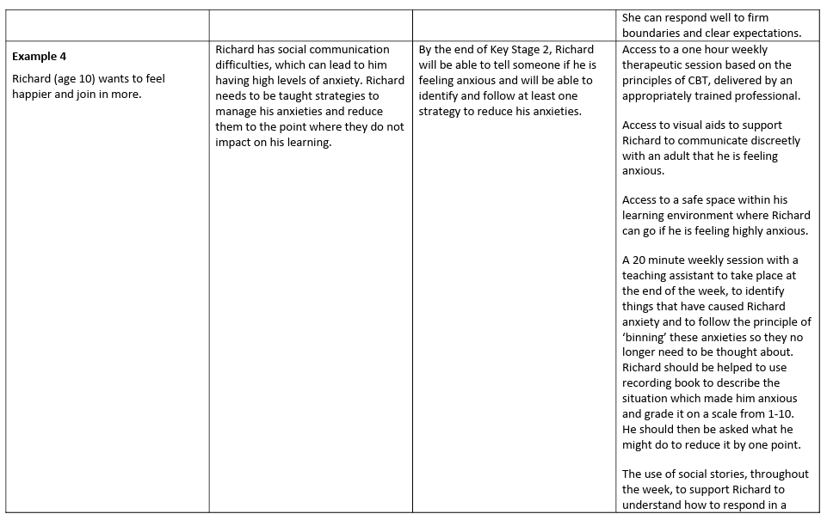

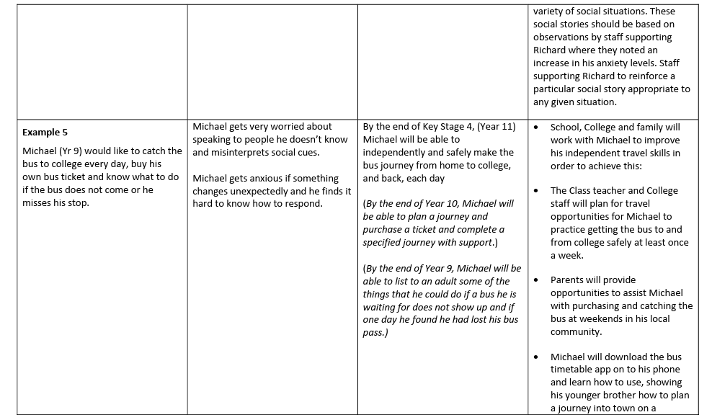
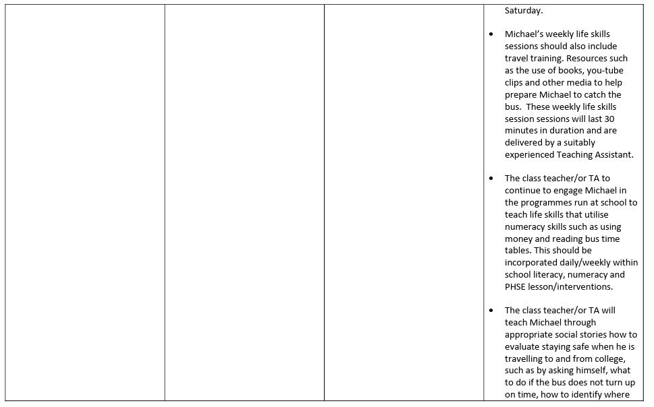
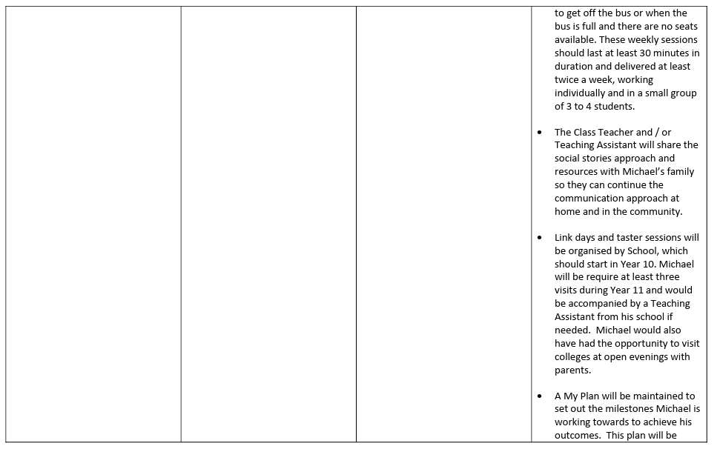
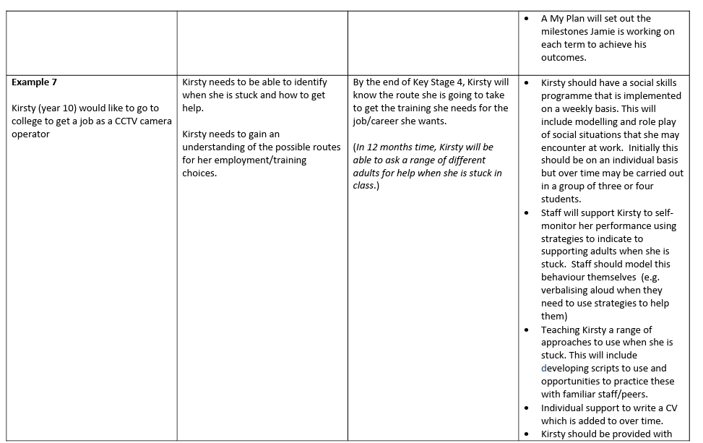

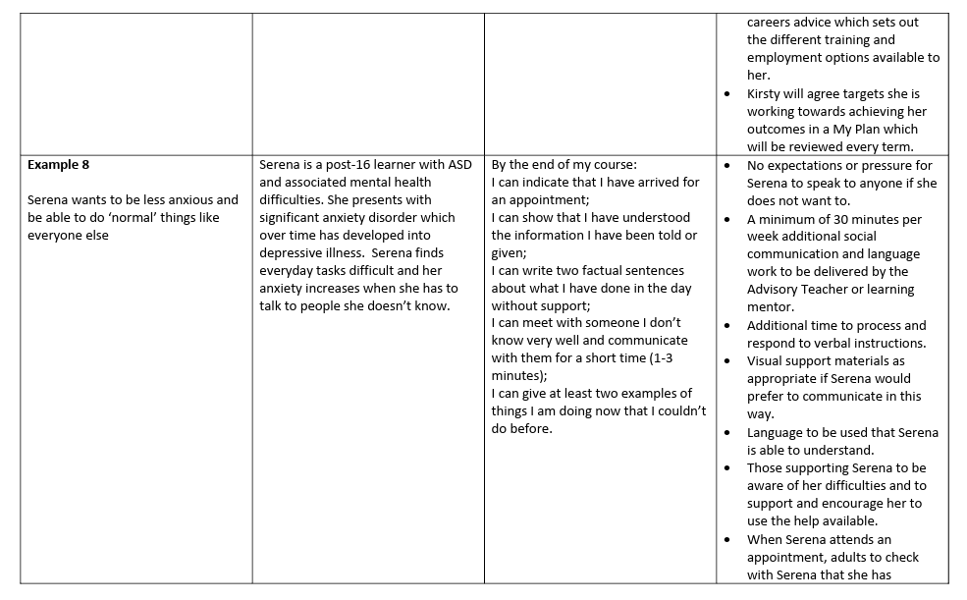
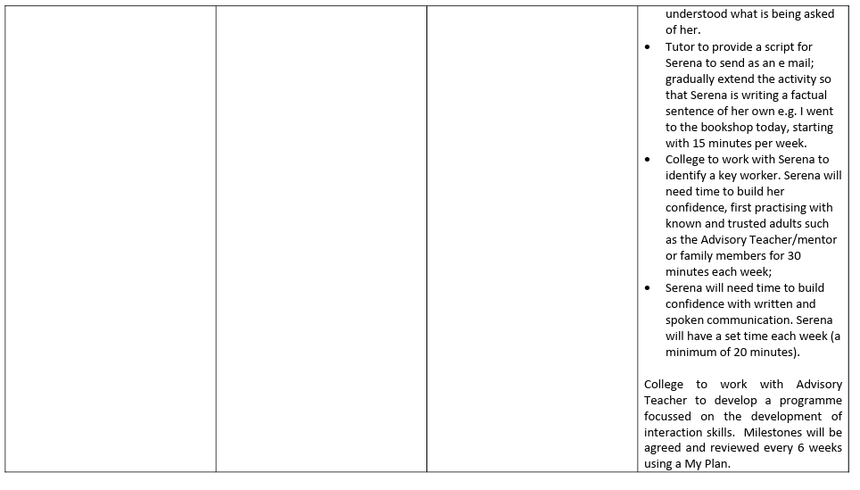

KEY NOTES/ Learning from example EHCP’s
Example 1
Most EHCP plans have By Whom as a separate column. In this example they are missing who will implement and manage the provision this is quite typical of LA’s which means its open to the school’s interpretation of said words. They refer to Adult – School Staff which is unacceptable, a QTS (Qualified Teacher Status) or Named 1.1 Support should be on there otherwise when they refer to “School Staff” this could mean school Janitor if not specified!
Who is giving the Pre-Teaching 5 x 10 minutes per day? Make sure it is quantified on your EHCP as is possible. Also consider if the Named person requires further training to do so, and if so, then that needs to be listed also in provision. “Respond well to clear praise & feedback” – what if the child has ASD and they struggle with communication and need direct communication this also needs to be listed here delving into the how it’s delivered which of course is key for ASD children.
Example 2
“The school will show the parents examples of PECS so they can implement at home” There is so much wrong with this statement. 1) what is PECS and 2) who is trained on it and does it require further updated training to encompass the Childs needs? Who in fact will show this to the parents? It could be the janitor as it is not specified! Remember SMART goals are needed ALWAYS encompassing every statement.
Example 3
“Sian will meet with mentor for 30 minutes each week alongside teacher and TA who will support the development of learning & self-esteem”
Is the teacher and mentor trained in building self esteem and what system will they use so that the child doesn’t feel overwhelmed or go into fawn mode and say yes to everything or say what they feel they think they need to hear? In this example, the child could have not received a SaLT assessment which looks for communication difficulties. A SaLT assessment can be requested during the initial EHPNA or during the draft stages to ensure it is specific enough. Again, QUANTIFY EVERYTHING!

Example 4

“Richard will have access to”
We all have access to everything for example, I have access to the ice cream van that comes around but my anxiety stops me from leaving the house and getting that ice cream! The support detailed here needs to be specific for e.g. Richard will have CBT Weekly in school provided by ‘Jo Bloggs’ outsource team who are qualified in specific Neuro Diverse CBT.

Example 5

Michael – According to this EHCP provision they are doing nothing but dictating to Michael what he should be doing in order to get on a bus!
Nothing here really supports him. Michael needs a Full SaLT assessment to ascertain his specific difficulties and from that he needs his ‘Key Worker’ be it QTS or Social Care (via social care assessment) to buddy him in practice using said Salt Tools which should be quantified and specified first in Section B then in F

Example 7

“Kirsty should have a social skills programme” Yes, she should and it should be listed here in section F as to how this will support her and how it will support her naming her key support and when this will happen for how long and how her progress will be measured. Also, what needs to be detailed is how the staff will know she is “stuck”, what if she has (which is suggested) communication difficulties? What level of training do these “staff” need to be able to identify in the first place?

Example 8

“no expectations for Serena to speak to anyone she does not want to”
This should read; ‘Mrs x’ to identify via SLCN / ASD (if applicable) training in order to be able to identify when Serena is ‘shut down’ and to learn strategies around this in order to assist her regulation. This will take place via x organisation and implemented with immediate effect with the goal of identify when Serena is unable to speak and advocate on her behalf. This will be monitored bi-weekly by X and reviewed Quarterly.

If your LA sends to you a vague draft EHC plan, you should go back to the LA explaining what provision is needed and why a particular level of detail is needed for that provision.

If your child’s final EHC plan is vague, you can ask for it to be made more specific at the next annual review, or appeal its contents if it has recently been issued.

If the EHC plan is specific, and provision is not being delivered, you should complain. Ipsea Website have model letters for all scenarios which we strongly recommend you use.

